Dylan Coulter October 19, 2023

ID#1896062

CS340

# CS 340 Final Project README

## About the Project/Project Title

The company Global Rain has agreed to work on a project for the company Grazloso Salvare. Grazloso Salvare is animal rescue and training company. The company has requested the development of a software application that can work with their existing data. This application will include a database and a dashboard that is web based and client facing. The company also requested a README file that will accompany our work. The application will allow users to work with a database of animals using the CRUD (create, read, update, and delete) operations. This application will utilize both the MongoDB database and Python. For the final project, the goal was to create an interactive dashboard to display the data. It was requested the data be display using three different charts. The first chart displays all the animal data and can be filtered and sorted in different ways. The next chart is a pie chart to display the data and help the user see a colorful visual of the different percentages of animals within the database. Lastly, we have the location chart which will show the animals location when selected. This was to be achieved by utilizing the Python coding language with the Dash framework.

## Motivation

The goal of this project was to create clean reusable code that would utilize both MongoDB and Python to manipulate a database of animals using the CRUD (create, read, update, and delete) operations. These operations are key to assisting Grazloso Salvare make changes, updates, and add to their already existing database of animals. For this project we use Python, the Mongo Database, Jupyter Notebook, and the Dash framework to create an interactive dashboard to display the provided animal shelter data. This dashboard was created to help the client locate animal that fit their requirements for dogs that would be good candidates to be rescue animals.

## Getting Started

Step 1: Open the terminal and import the acc_shelter_outcome.csv file

Step 2: Create both a complex and simple index that will parse the stored data.

Step 3: Authenticate user will need to create both an admin and user account to allow access to the database.

Step 4: The user would need to have access to or install the most recent version of Python.

Step 5: Use a notebook to run the program.

Step 6: Connect to dash. This can be done by clicking the link or typing in the address.

## Installation

Requirements to run the program include MongoDB so we can access the database. An up to date version of both Python and Jupyter Notebook so both .py and .ipynb files can be run. Access to libraries such as PyMongo, Leaflet, Dash, Plotly, Pandas to develop functions in the dash.

## Usage

*Use this space to show useful examples of how your project works and how it can be used. Be sure to include examples of your code, tests, and screenshots.*

### Code Example

*Show what the library does as concisely as possible. Developers should be able to figure out how your project solves their problem by looking at the code example. Make sure that your code is short and concise.*

***Python file: animal_shelter.py***

This Python file was created to utilize the CRUD operations to allow the user to create, read, update, and delete the data within the database.

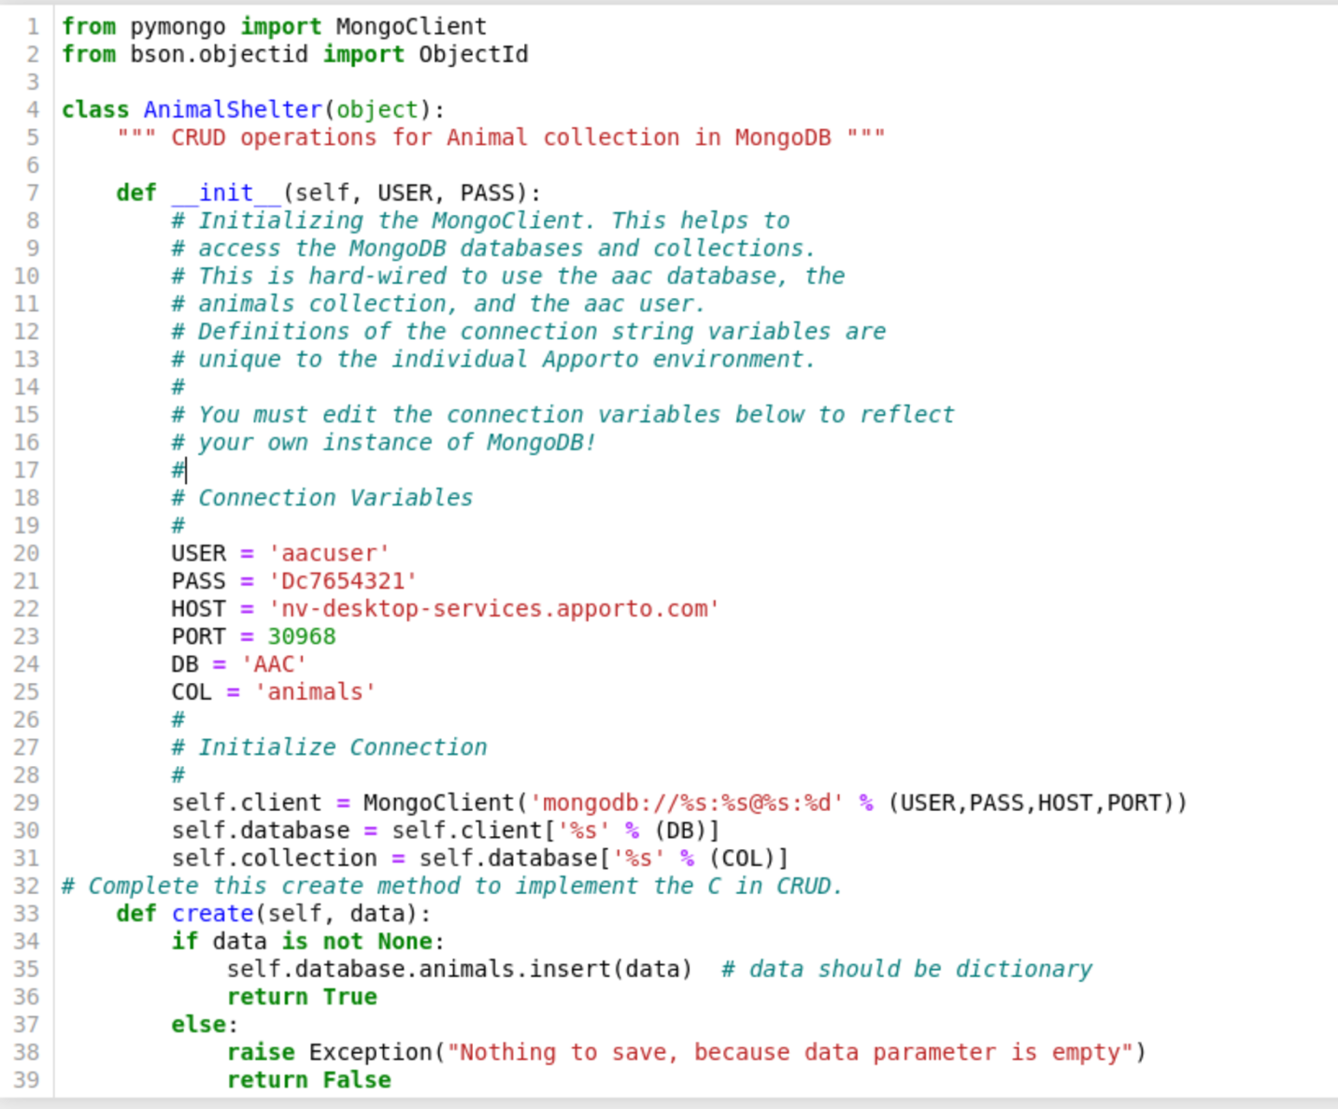

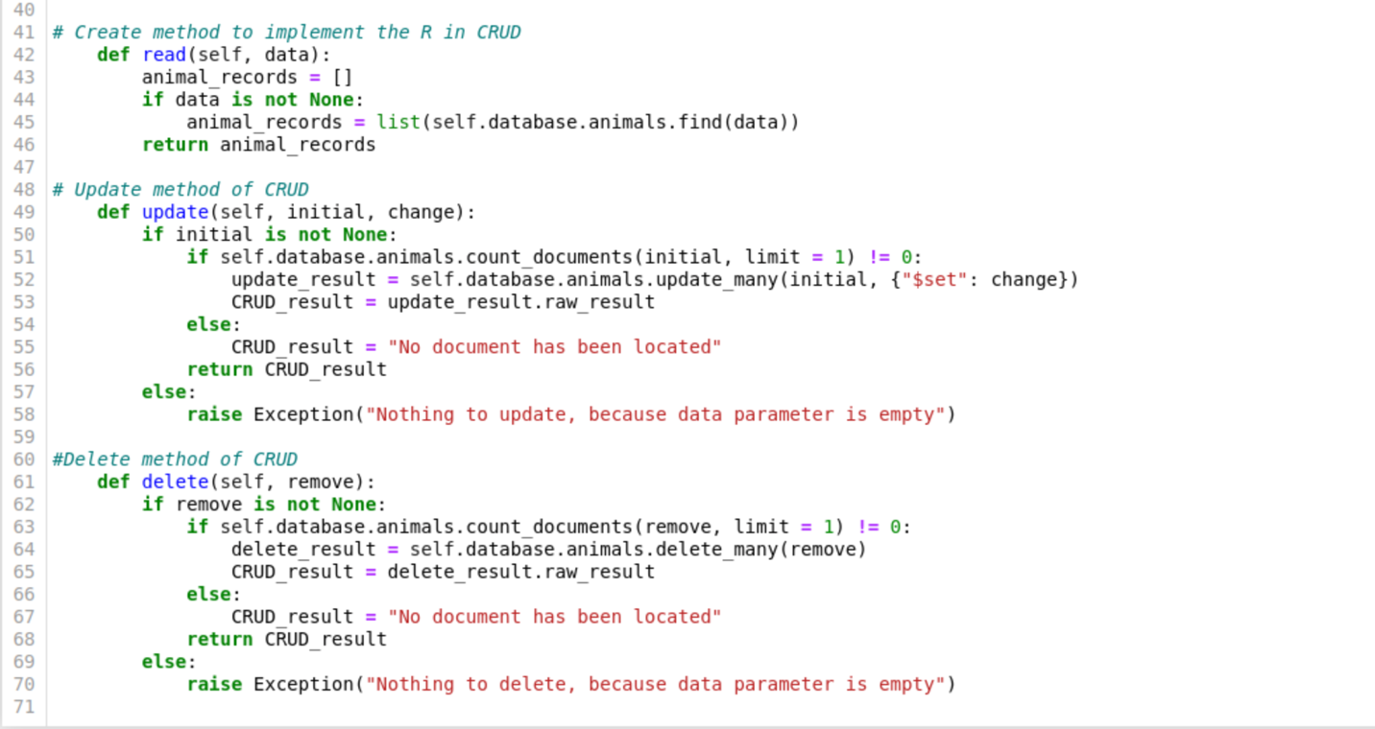

**ProjectTwoDashboard.ipynb**

This file was created to take the data from the provide csv file and to display an interactive dash for the client. The dashboard displays a unique identifier, the company logo, a slogan, and another image containing a rescue animal. This file contains code to display three different charts. A chart to display the animal shelter data, a pie chart, and a location chart. We also included sorting and filtering options with the use of radio buttons. These include filters for water rescue, mountain or wilderness rescue, disaster or individual tracking, and reset.

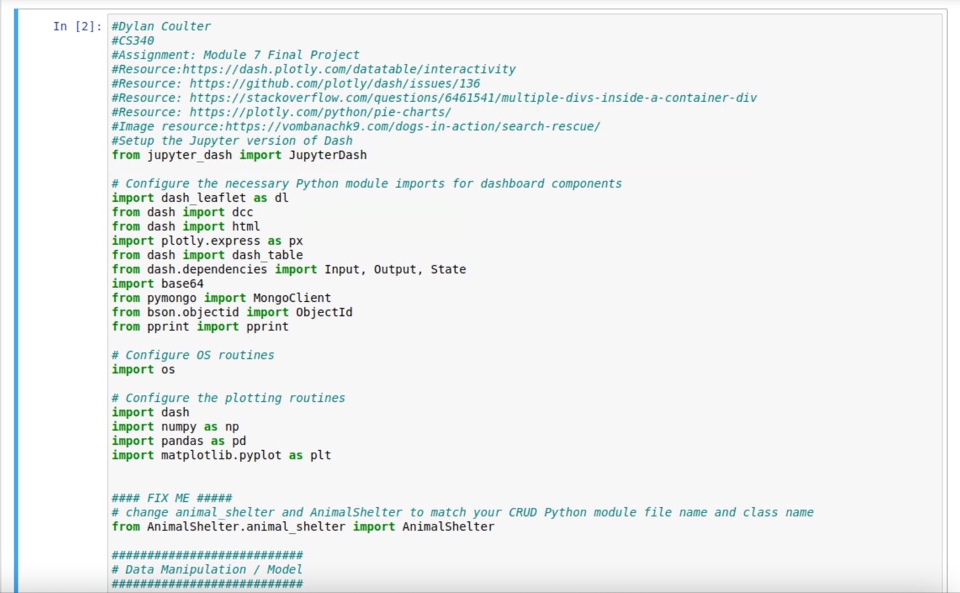

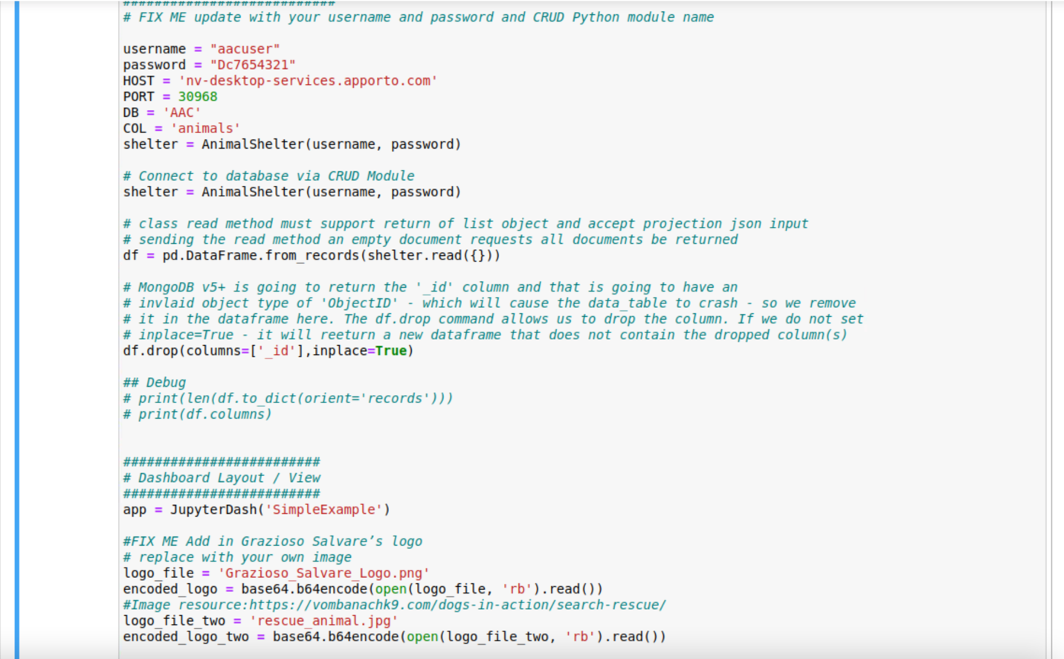

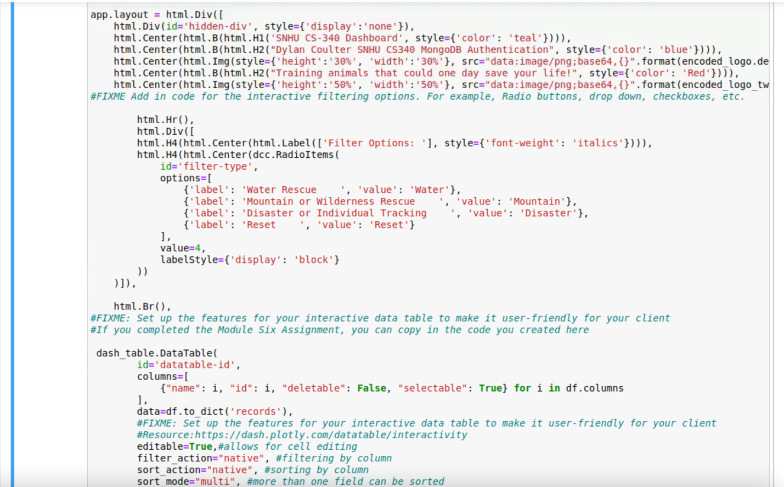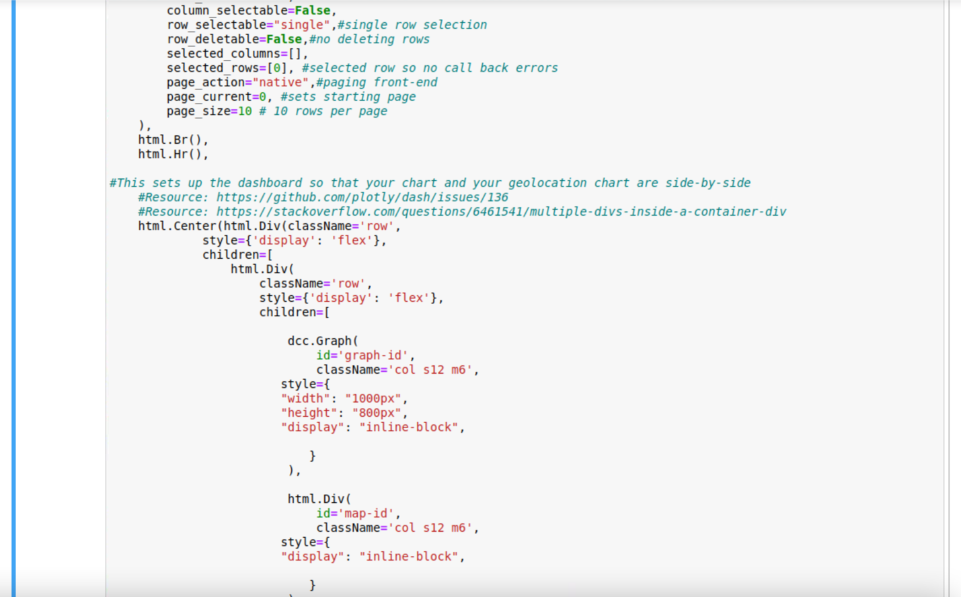

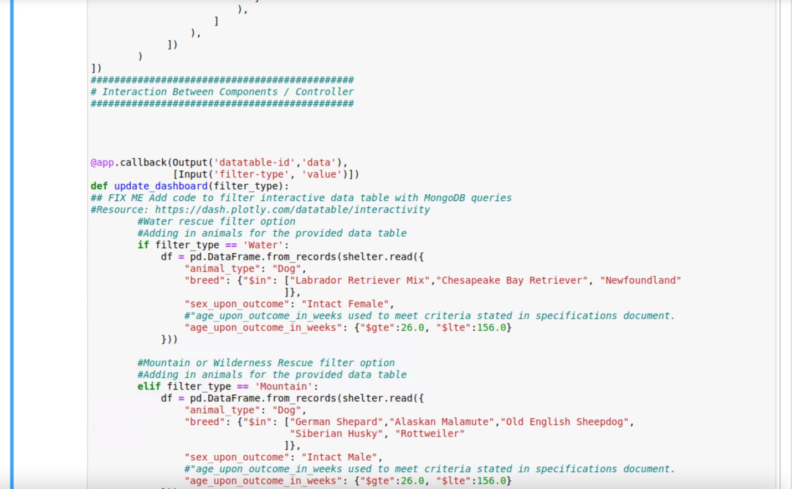

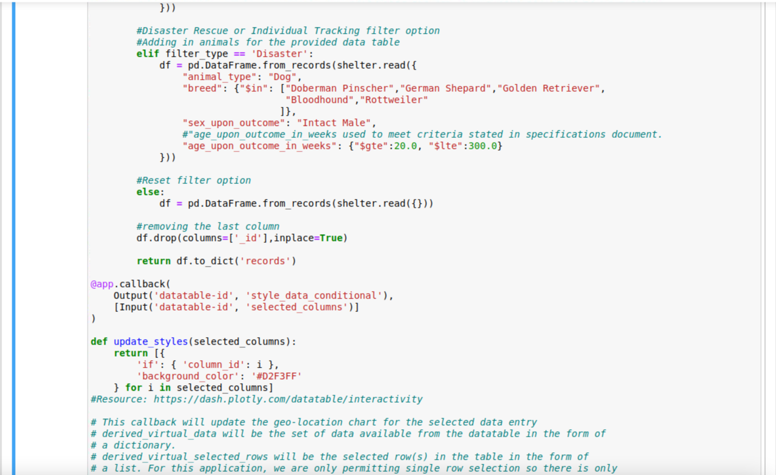

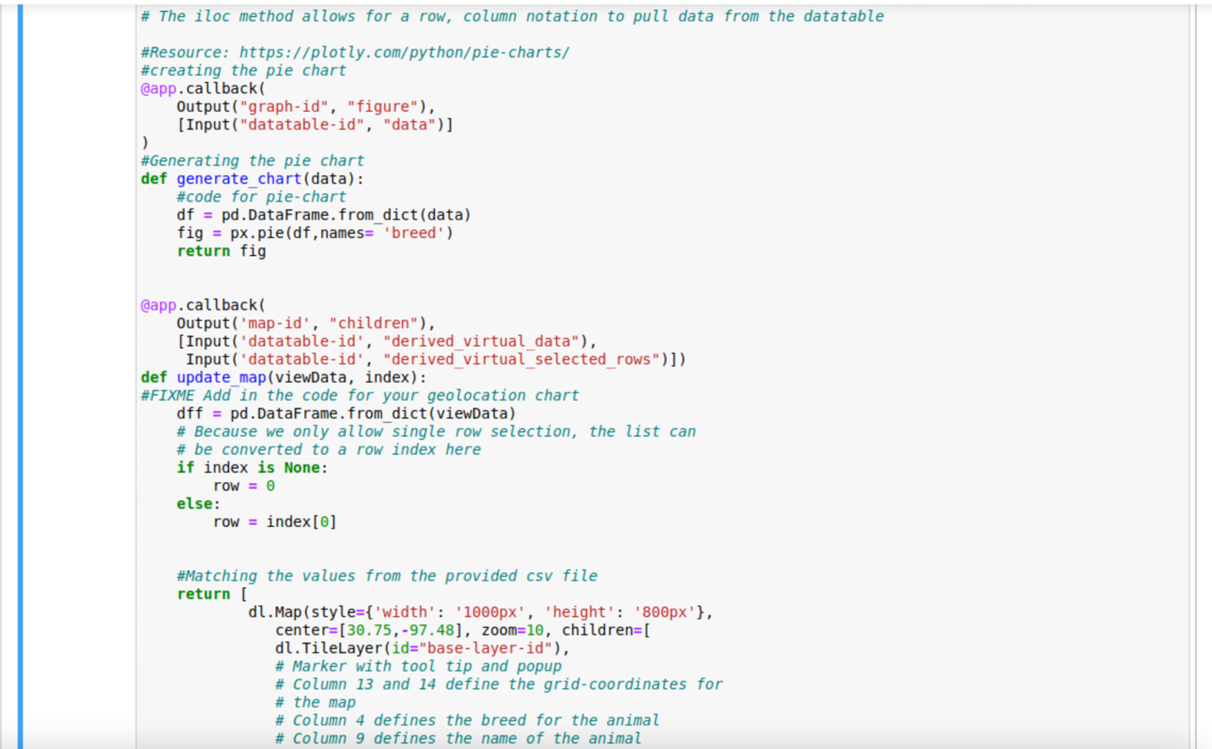

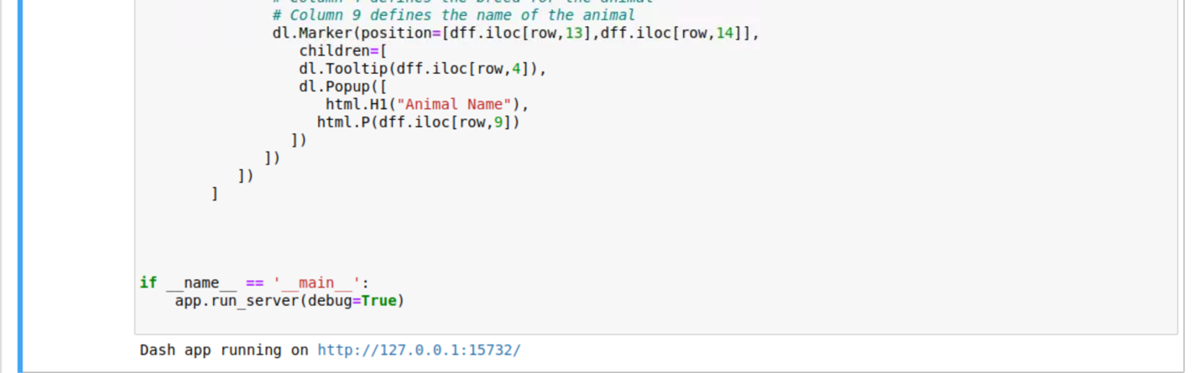

### Screenshots

*Provide screenshots that demonstrate your work.*

**Uploading the Austin Animal Center (AAC) Outcomes data set into MongoDB**

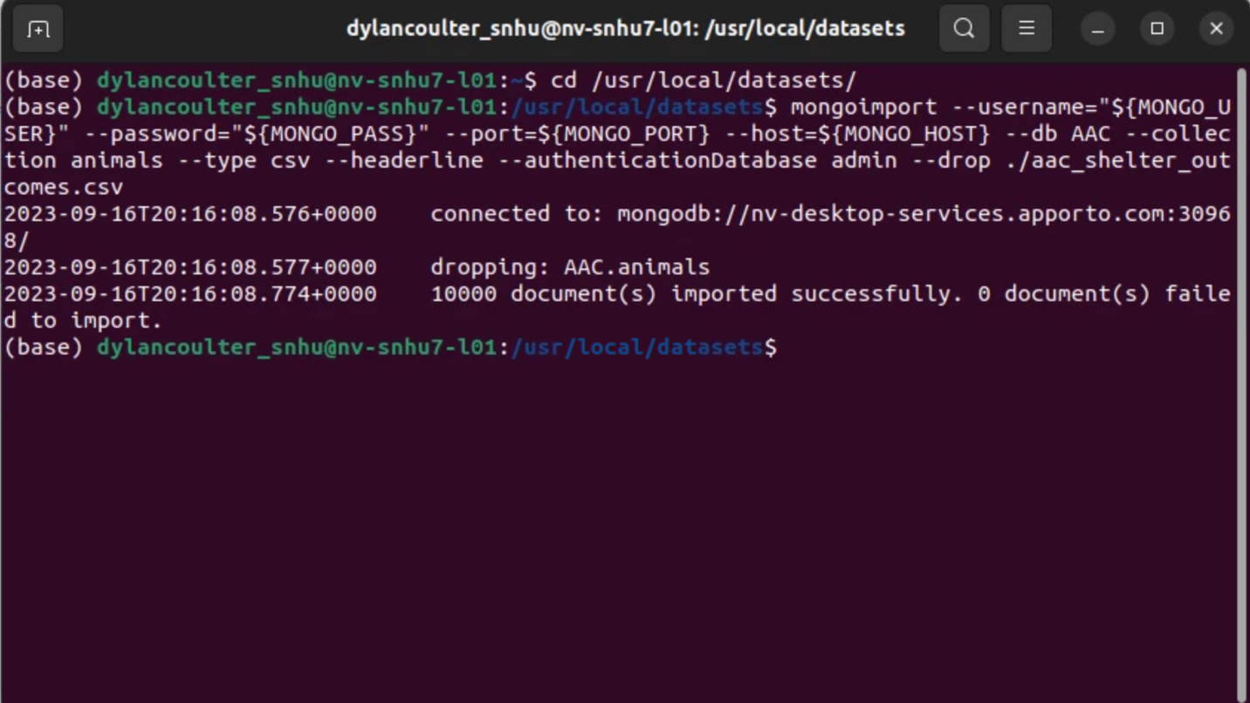

**Mongo Database**

**Creating simple index for Breed**

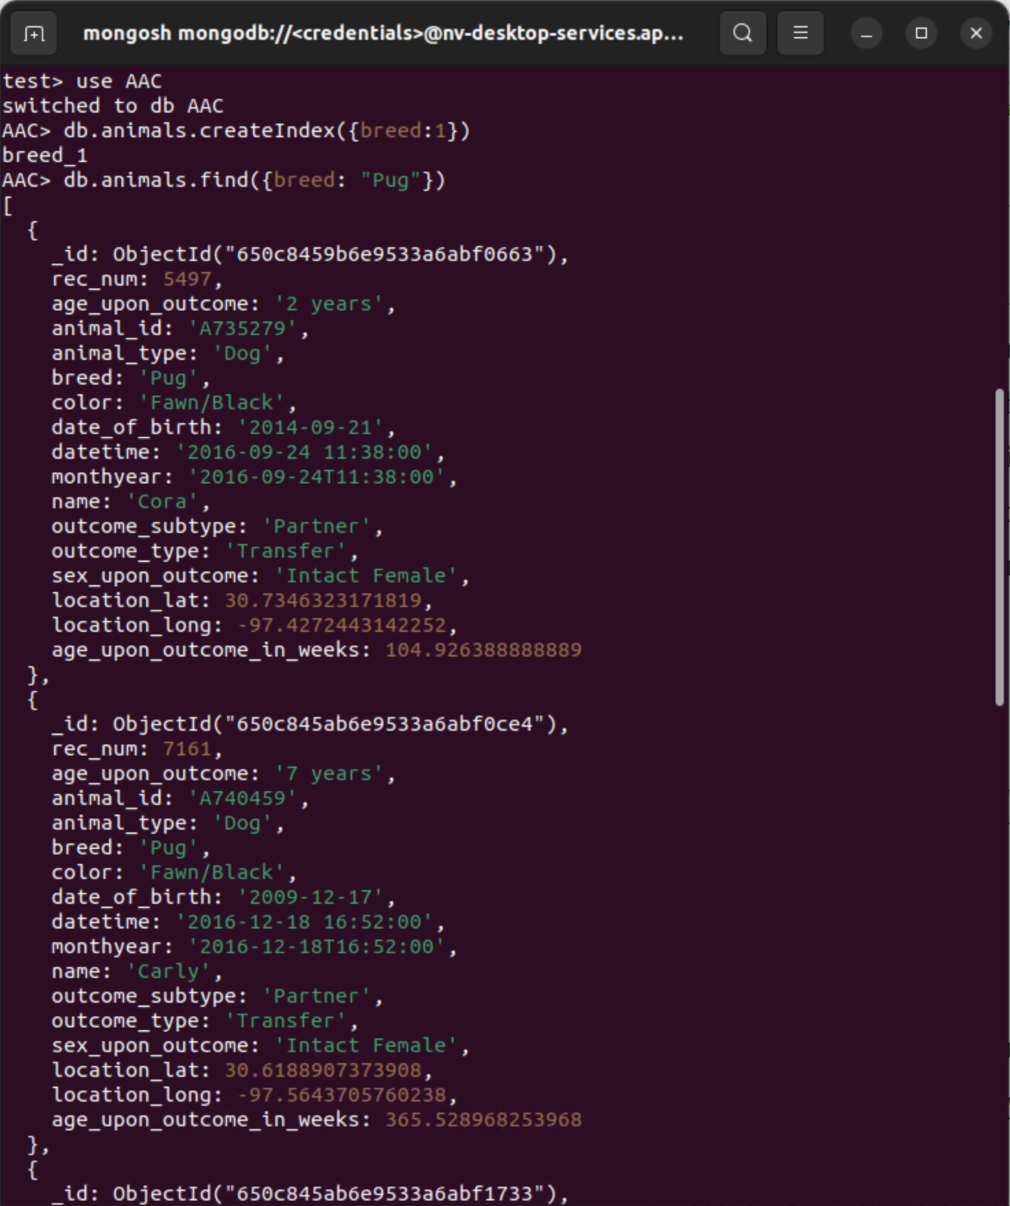

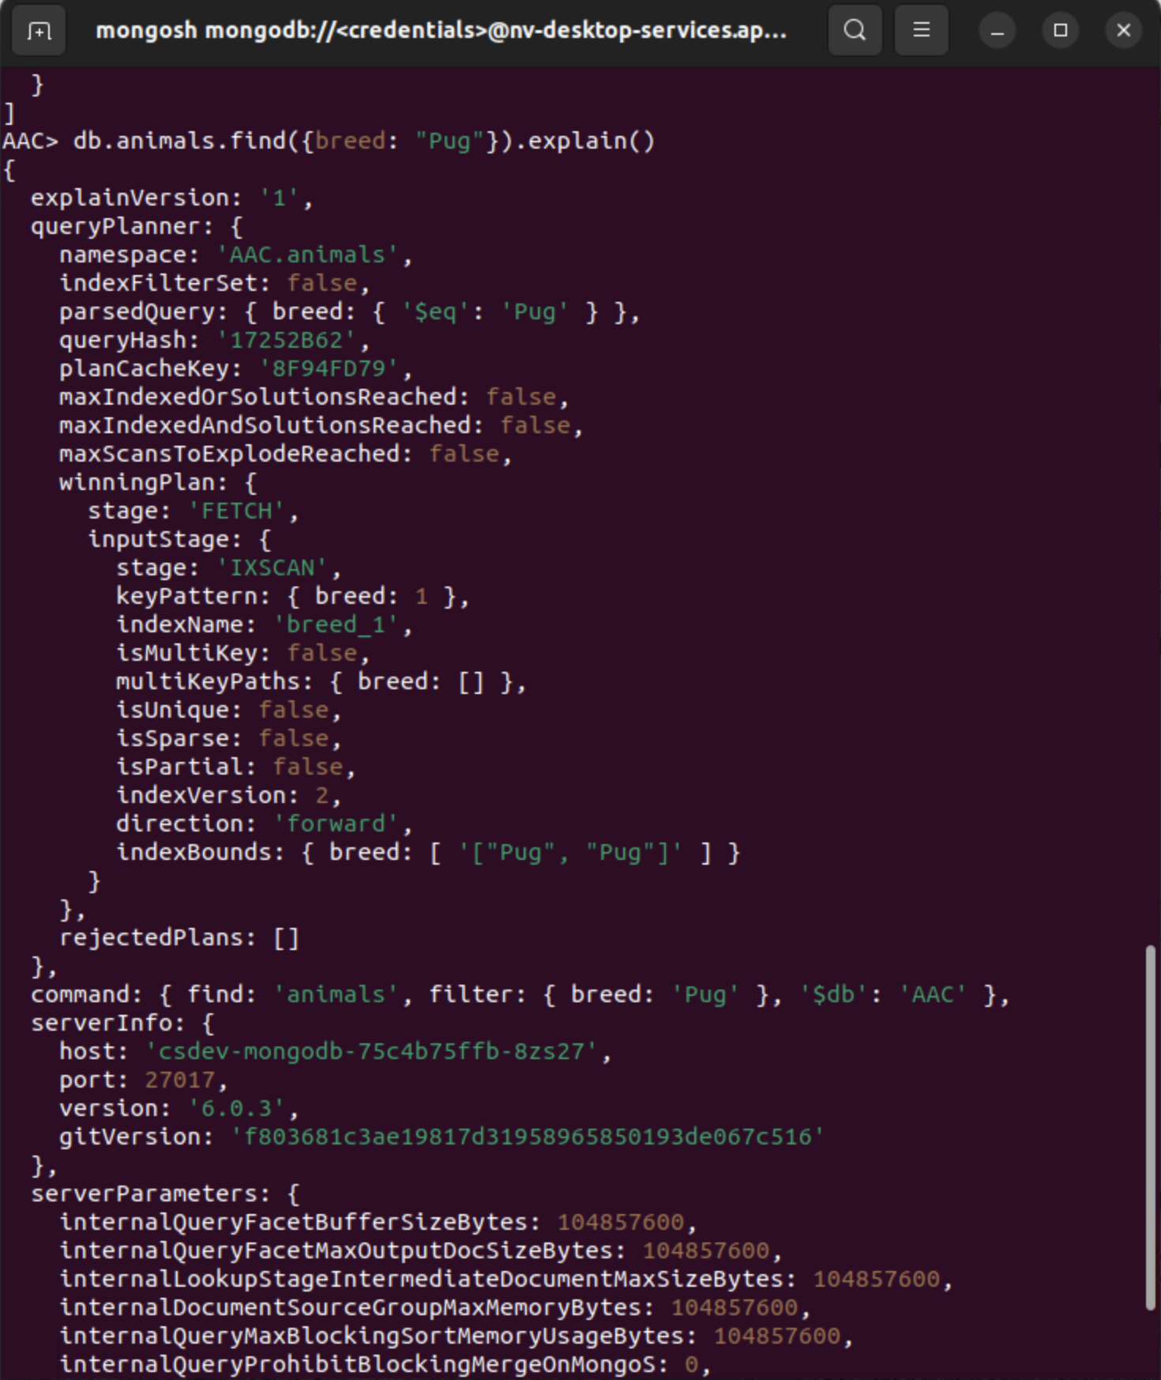

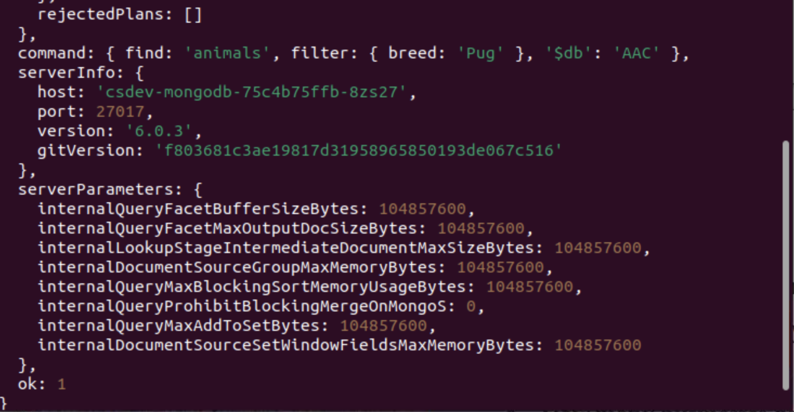

**Creating a compound index for Breed**

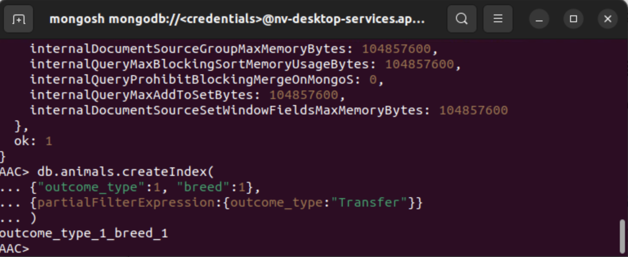

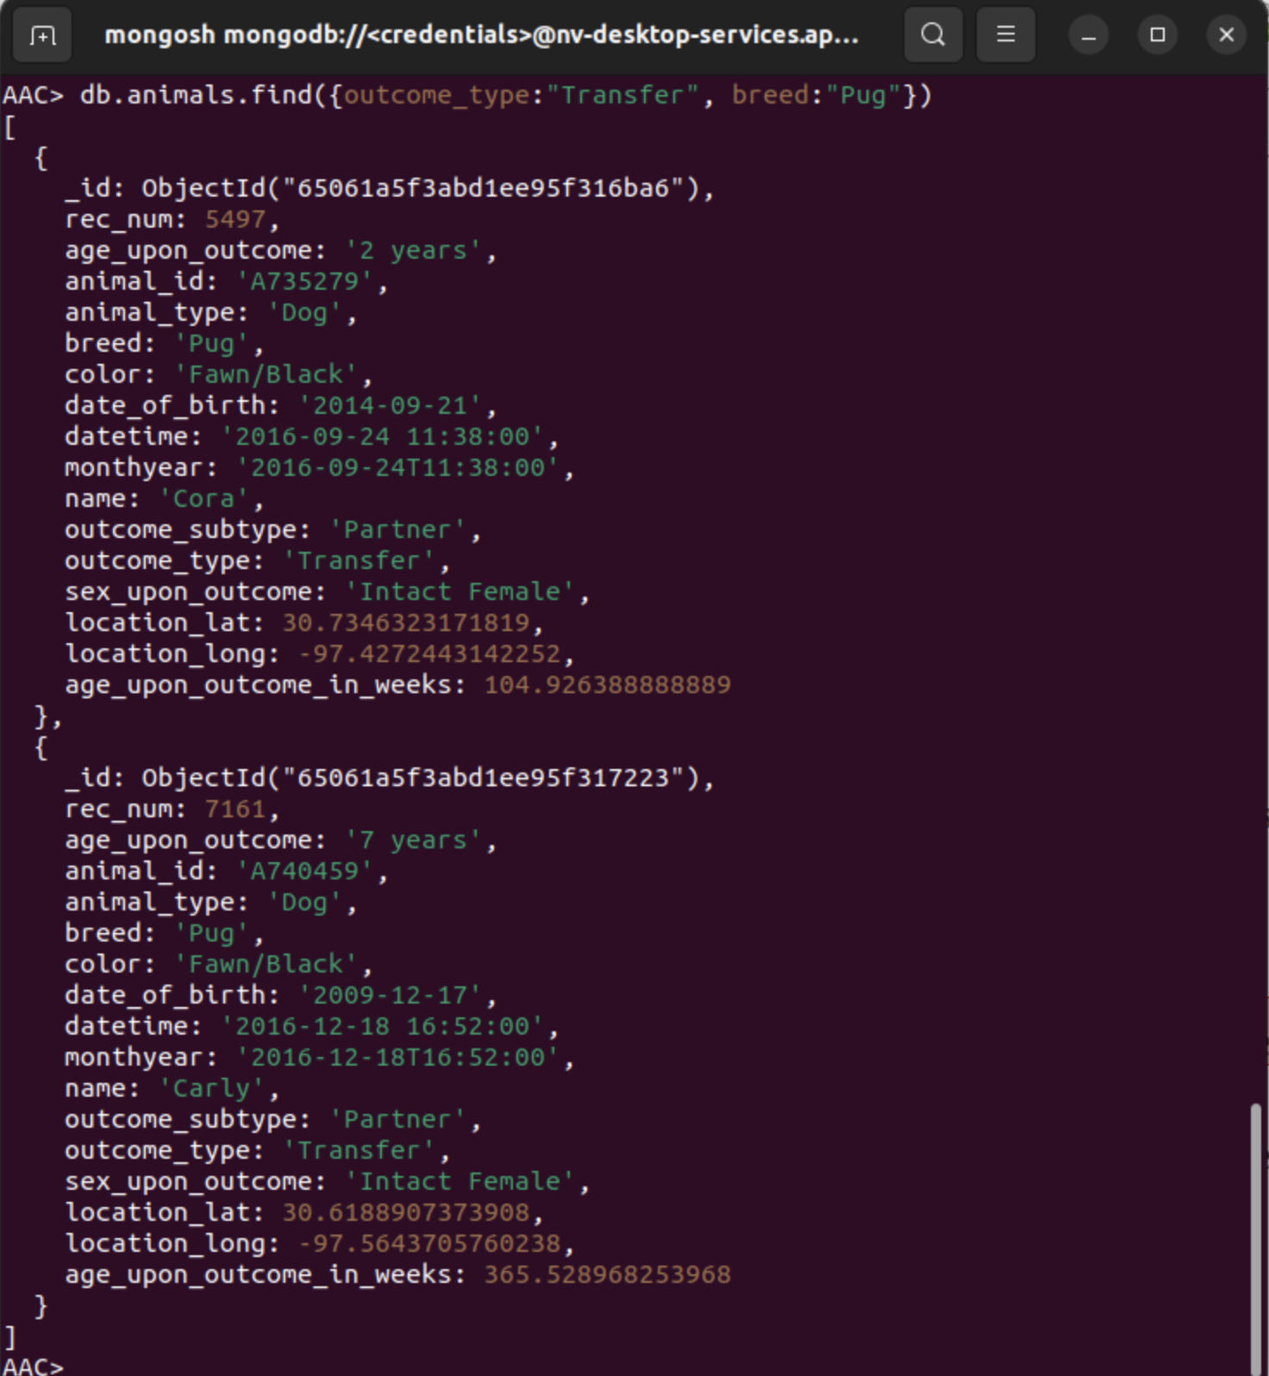

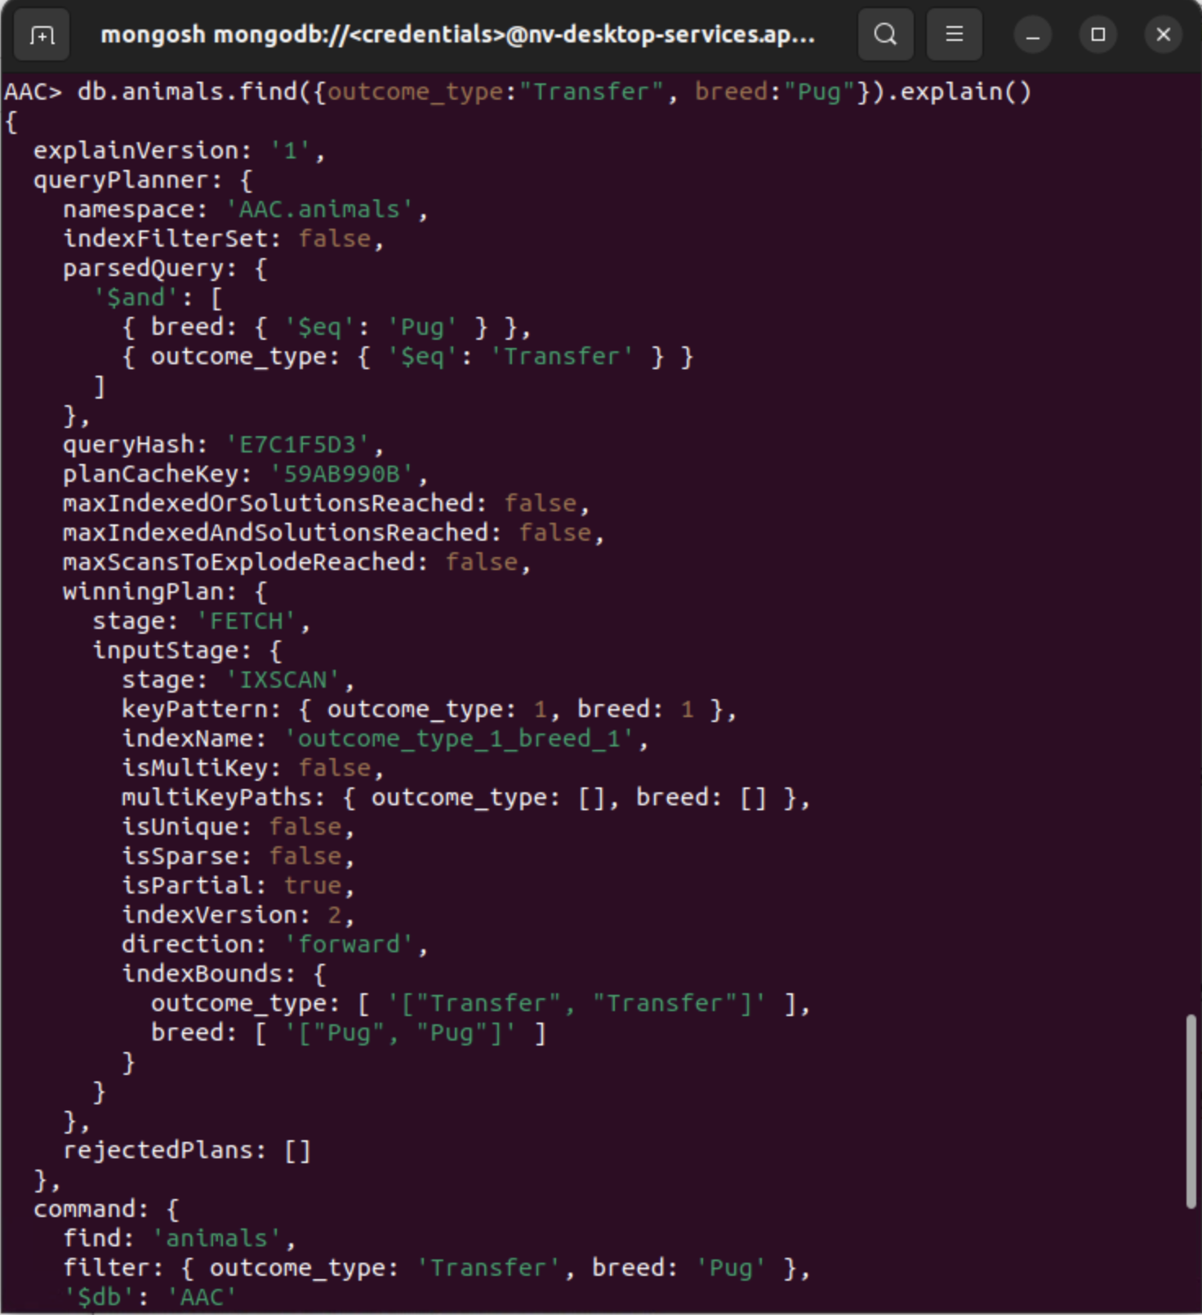

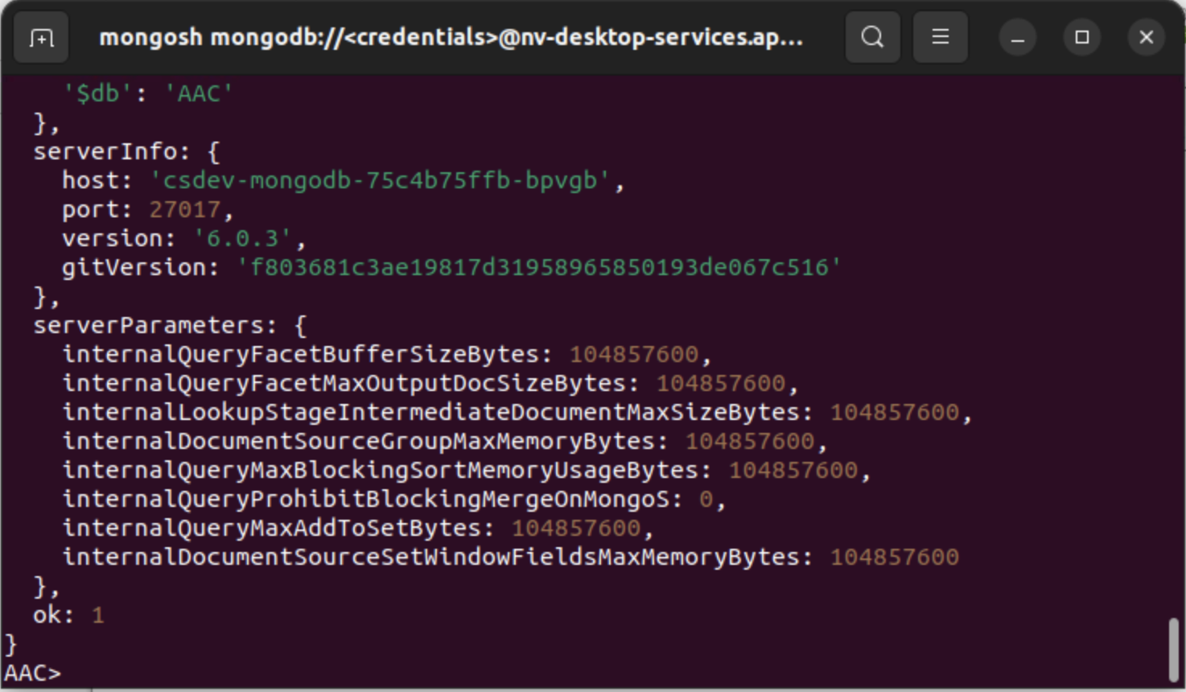

**User Authentication**

**Creating and Verifying Admin account**

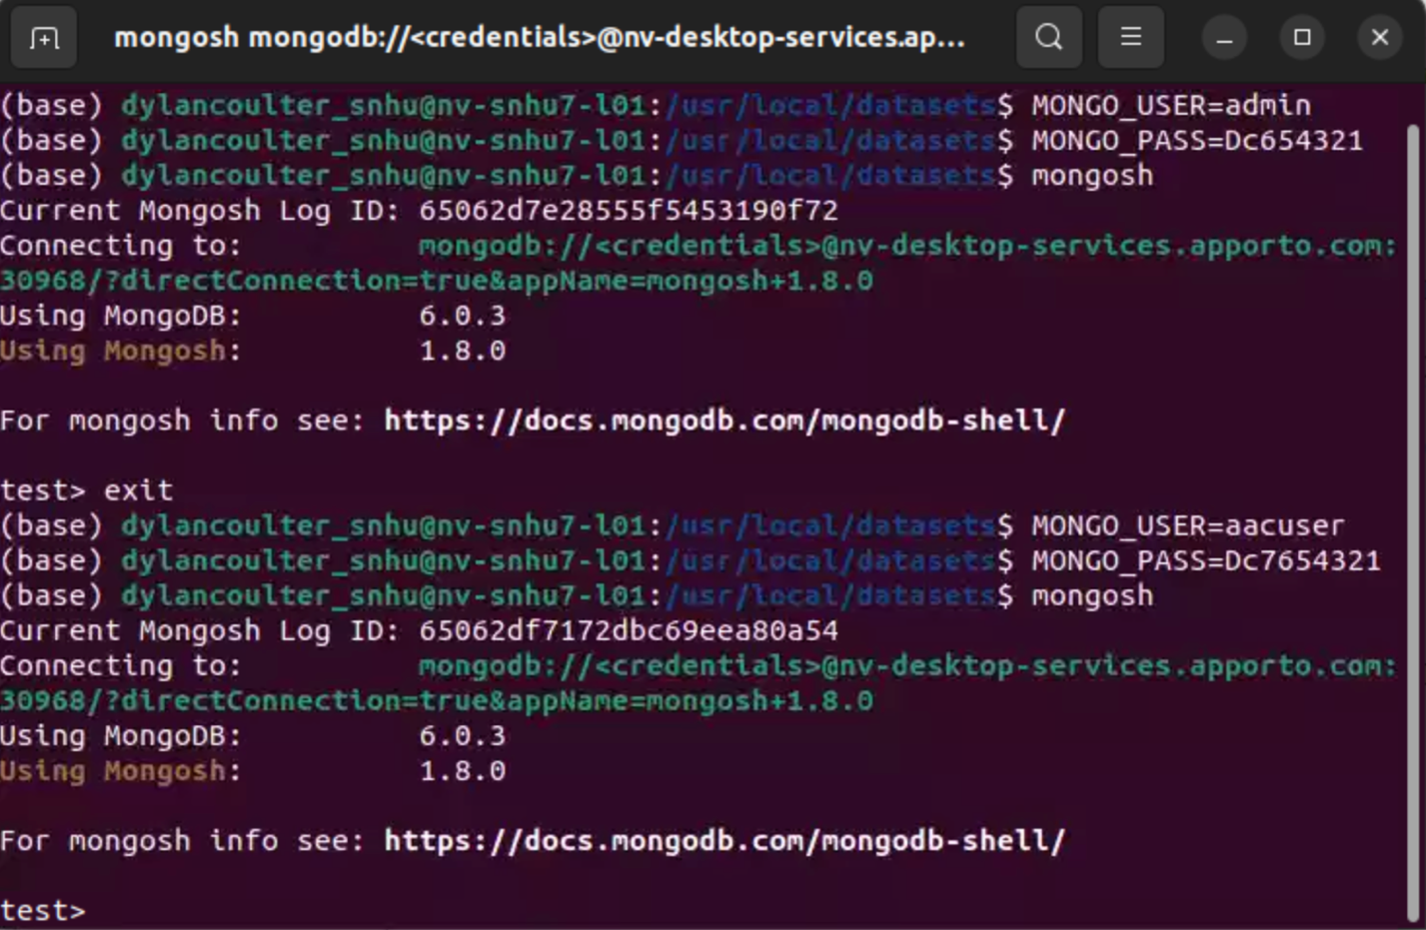

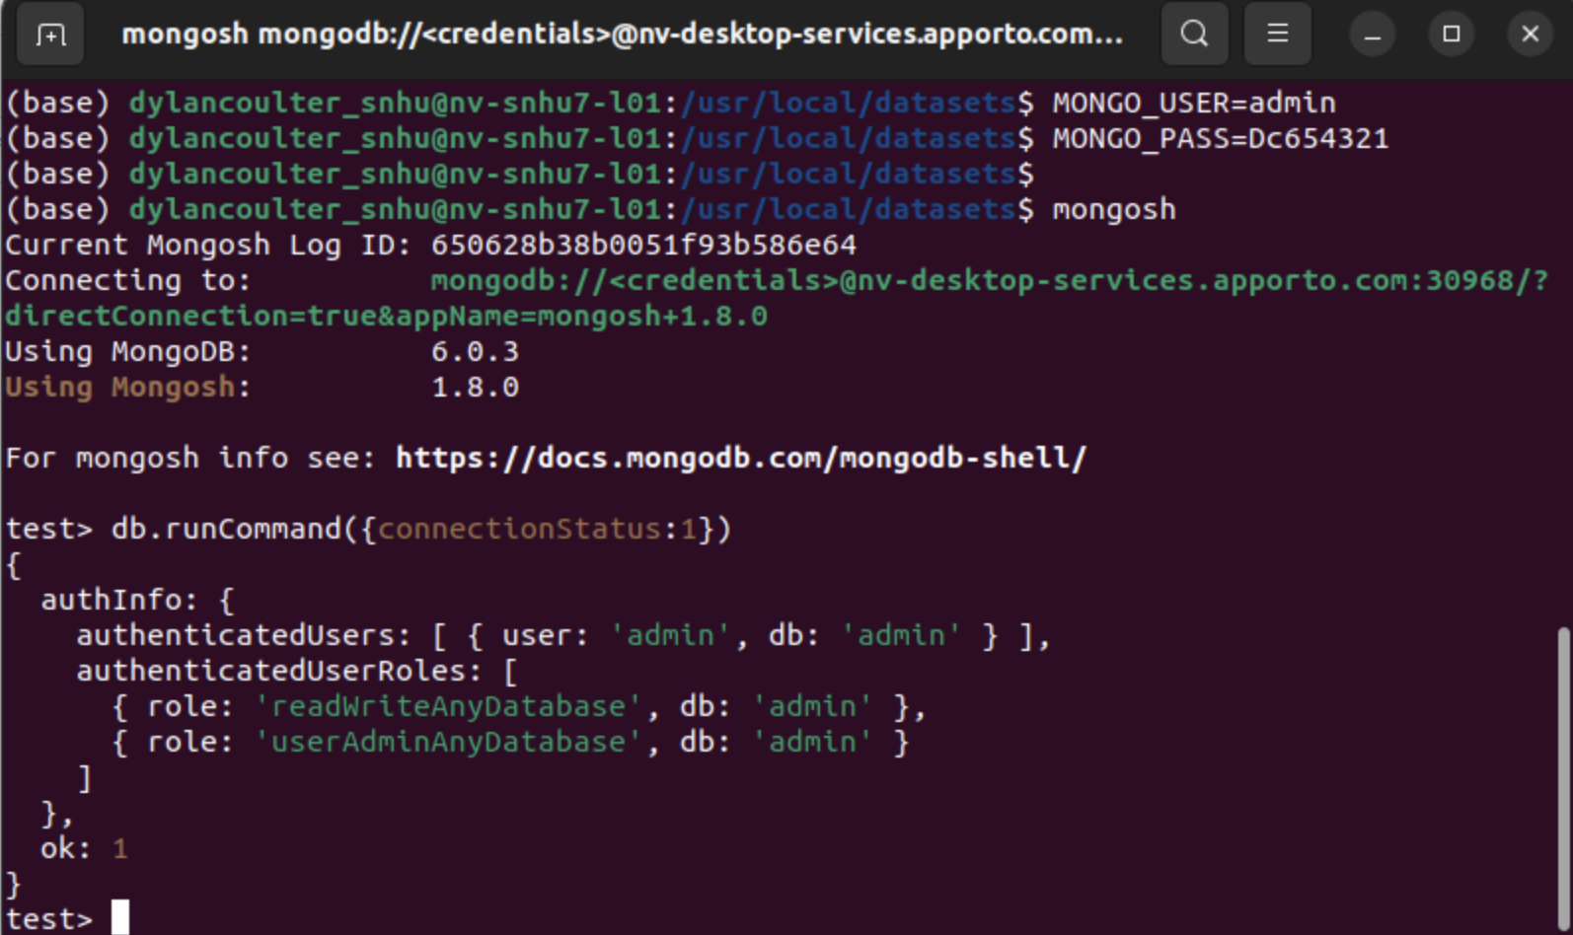

**Creating and Verifying aacuser account**



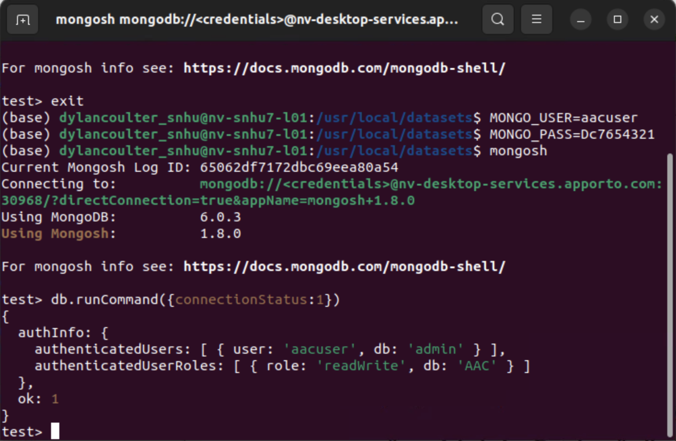

**Jupyter Notebook**

**Authentication**



***Create*- A method that inserts a document into a specified MongoDB database and collection**

Input -> argument to function should be the key/value lookup pair to use with the MongoDB driver find API call.

Return -> “True” if successful insert, else “False”.

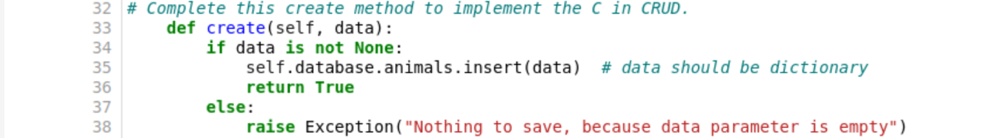

**Creating New Animal**

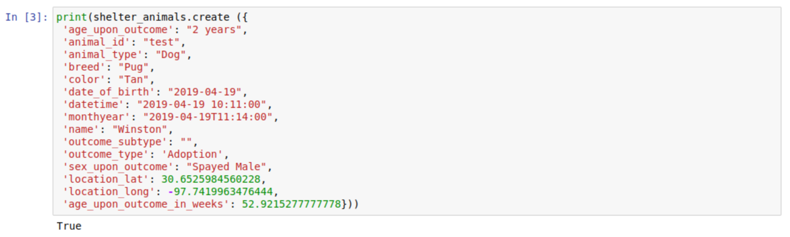

**Invalid Animal Creation**

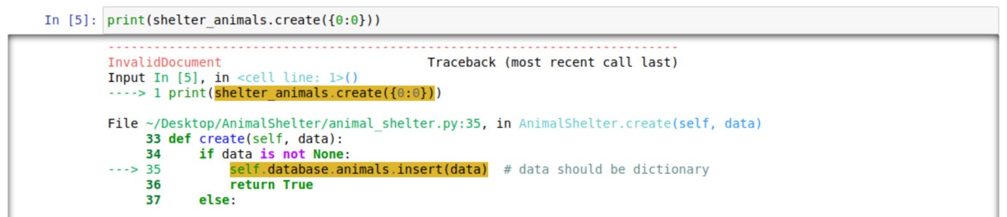

***Read*- a method that queries for document(s) from a specified MongoDB database and specified collection**

Input -> arguments to function should be the key/value lookup pair to use with the MongoDB driver find API call.

Return -> result in a list if the command is successful, else an empty list.

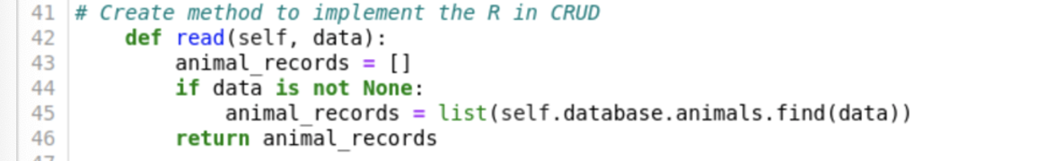

**Search and read new animal**

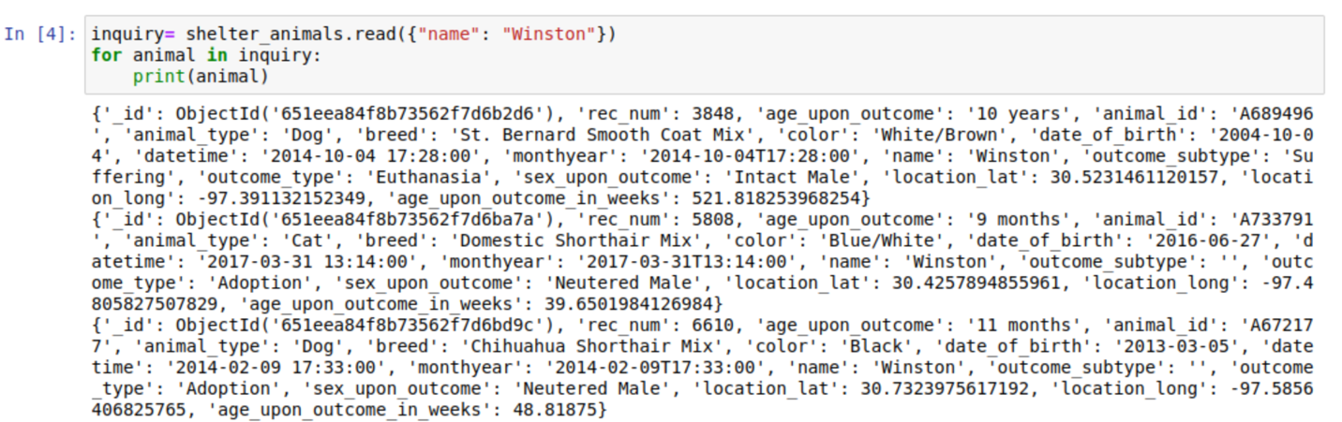



**Invalid Search and Read**

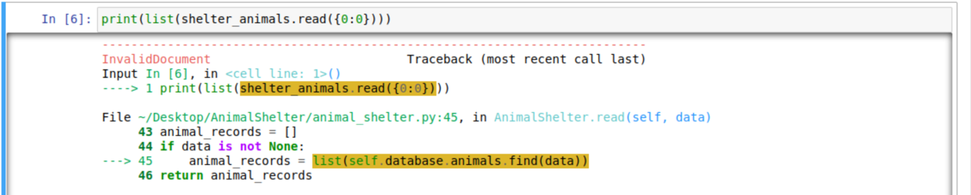

***Update- A* method that queries for and changes document(s) from a specified MongoDB database and specified collection**

Input -> arguments to function should be the key/value lookup pair to use with the MongoDB driver **Find API** call. The last argument to function will be a set of key/value pairs in the data type acceptable to the MongoDB driver update_one() or update_many() API call.

Return -> The number of objects modified in the collection.

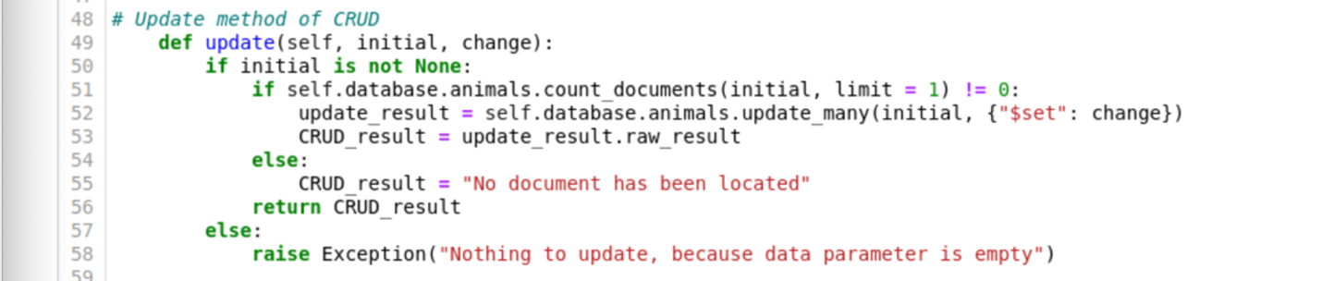

**Update animal**





**Invalid Update**

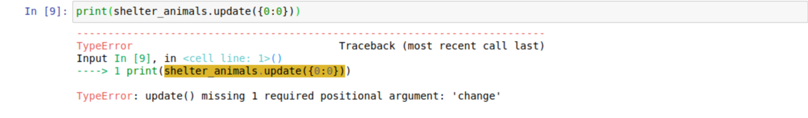

***Delete- A* method that queries for and removes document(s) from a specified MongoDB database and specified collection**

Input -> arguments to function should be the key/value lookup pair to use with the MongoDB driver find API call.

Return -> The number of objects removed from the collection.

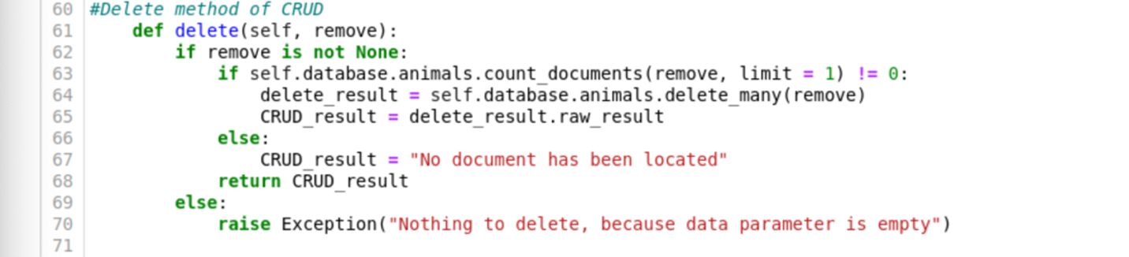

**Delete animal**



**Invalid Delete**

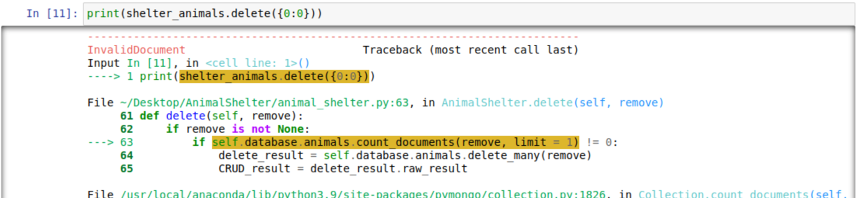

**Grazioso Salvare Dashboard**

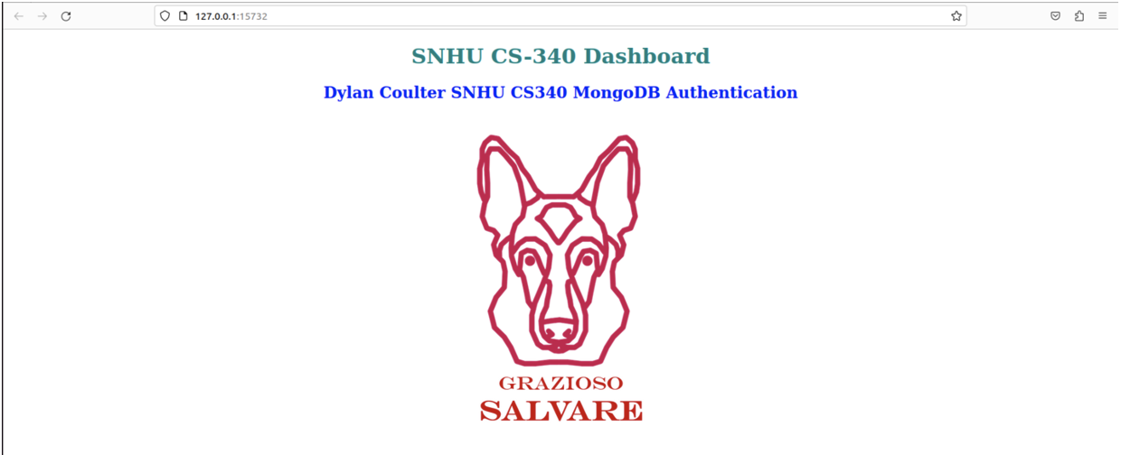

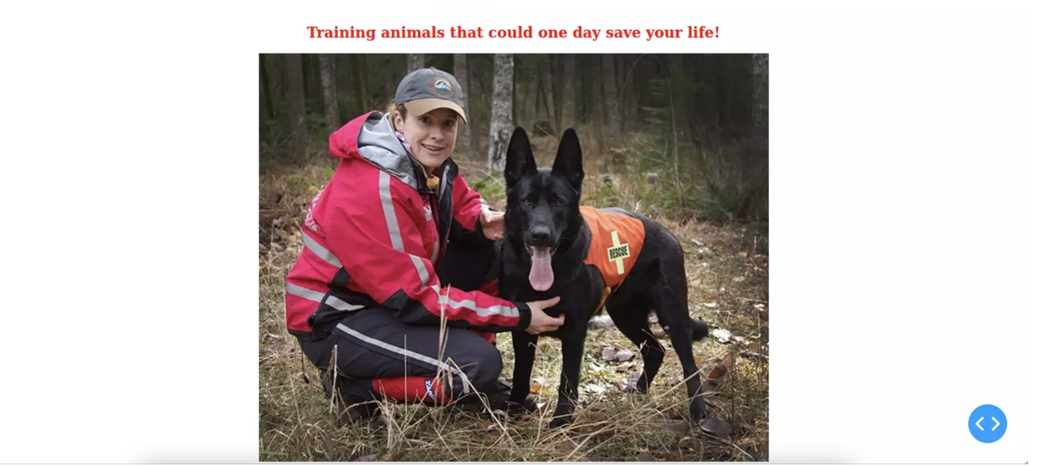

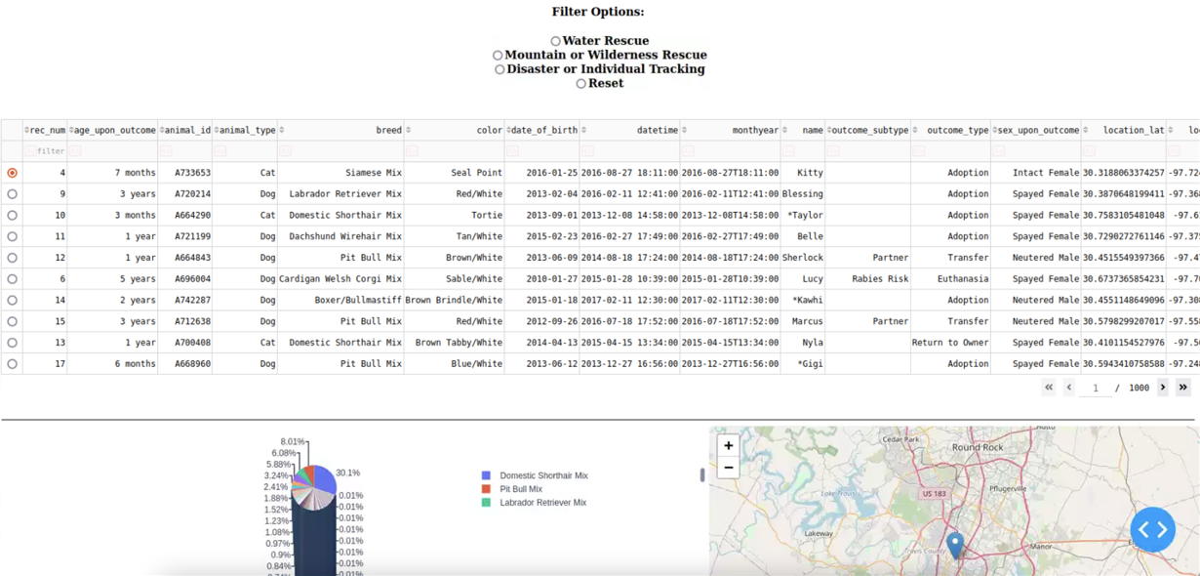

**Sorting Chart by Breed**

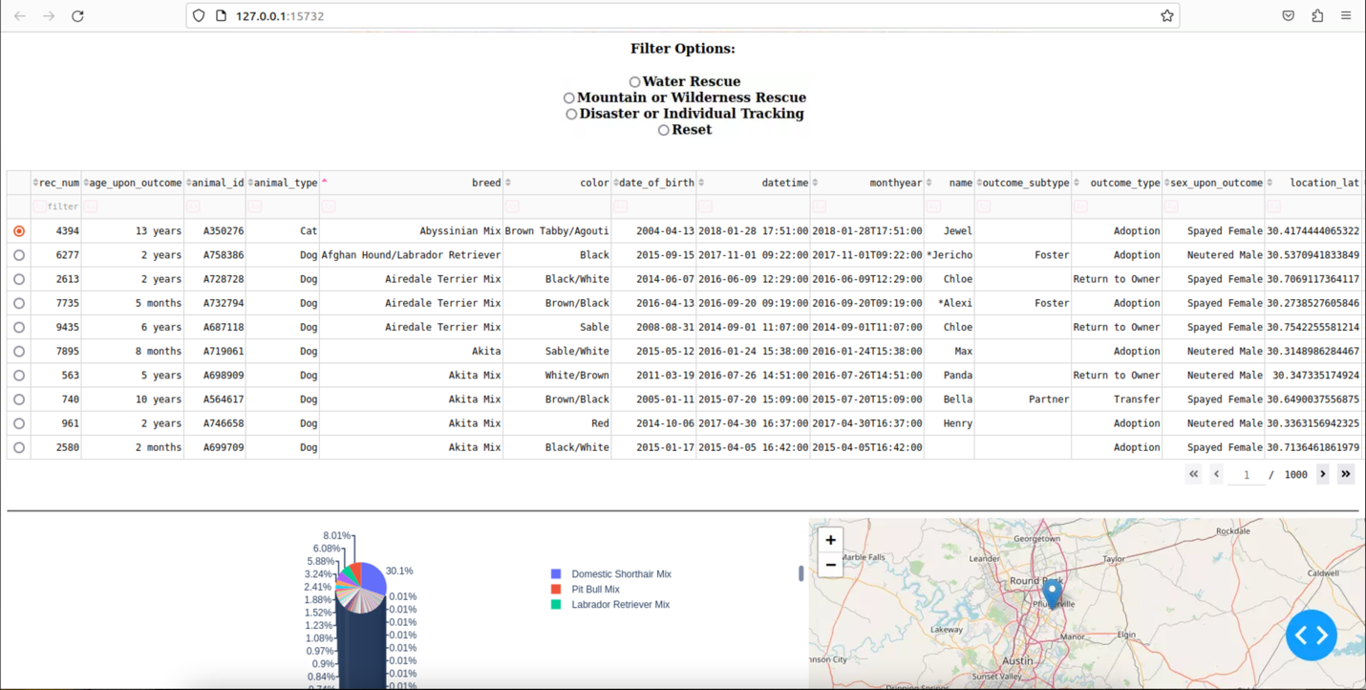

**Sorting Chart by Animal Color**

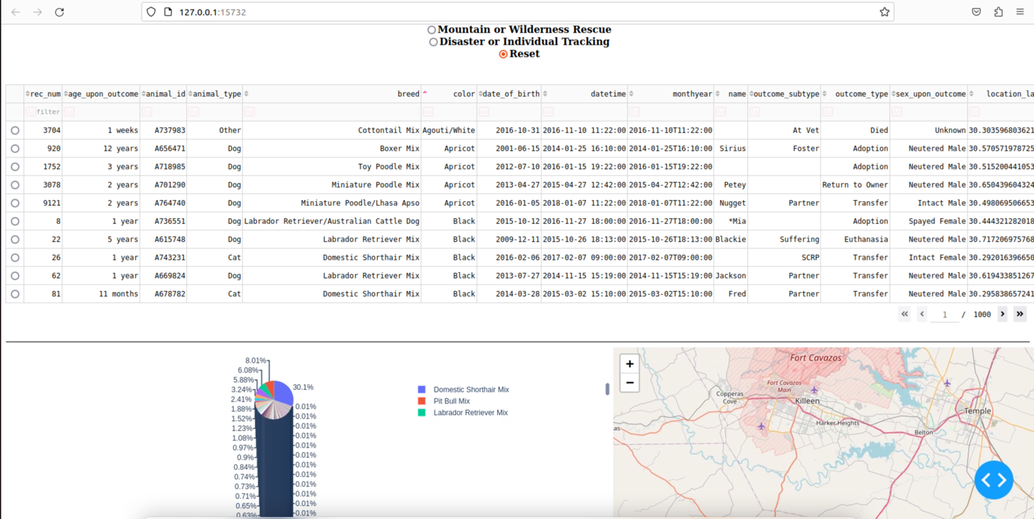

**Water Rescue Filter Option**

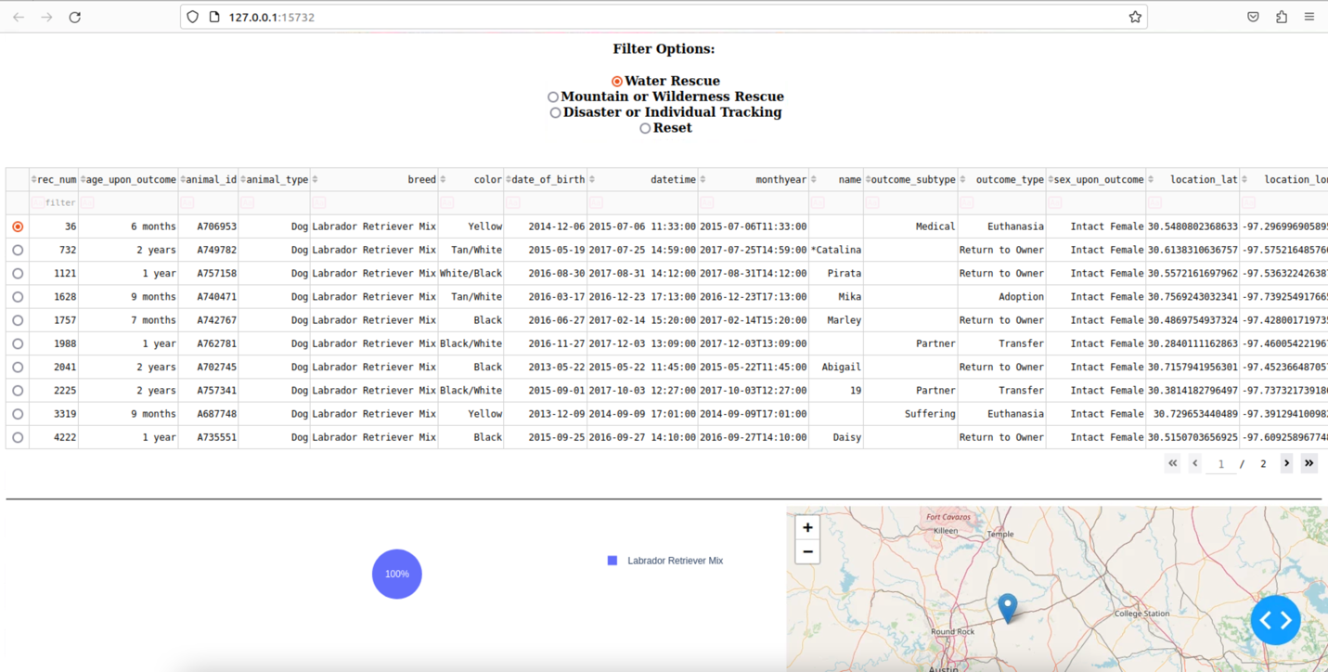

**Mountain or Wilderness Rescue Filter Option**

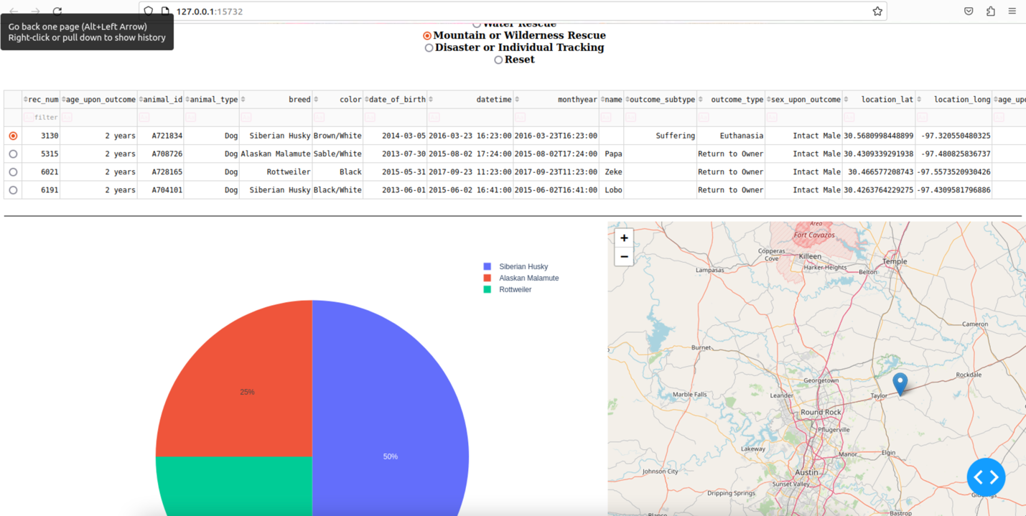



**Disaster or Individual Tracking Filter Option**

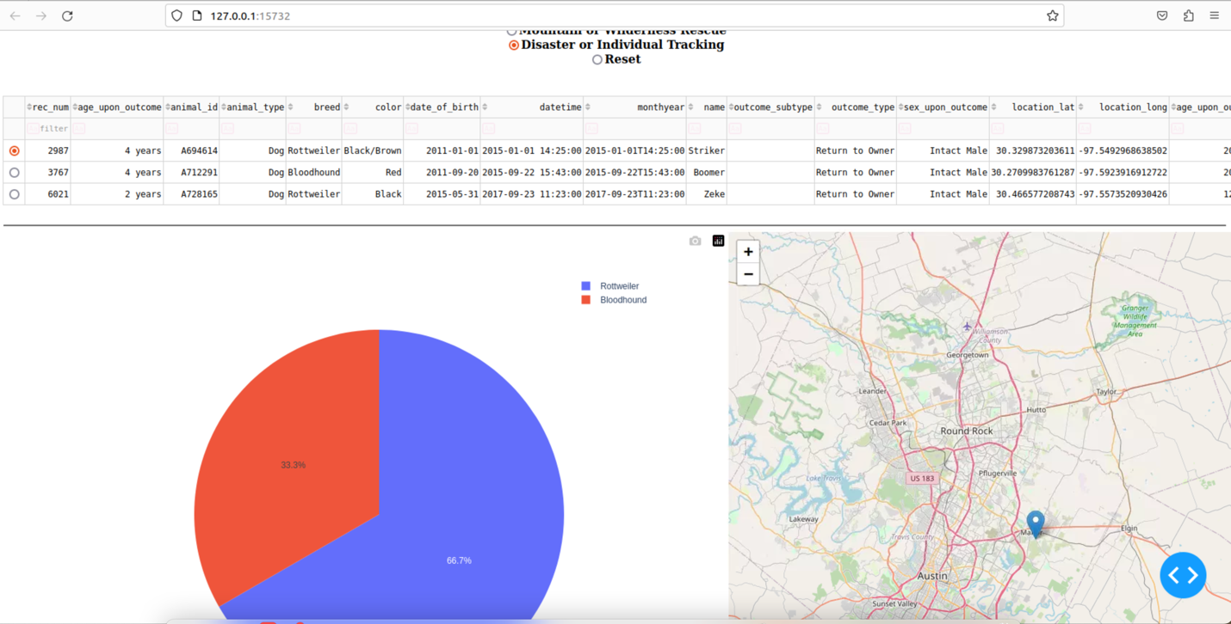

**Reset Filter Option**

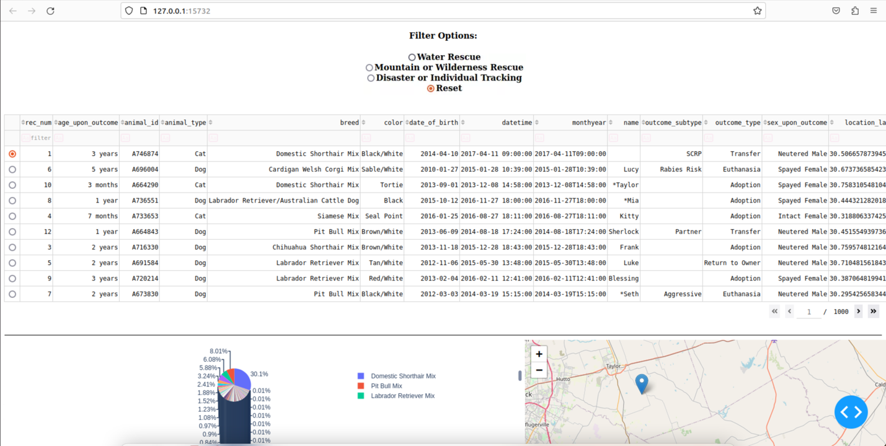

**Describe the tools used to achieve this functionality and a rationale for why these tools were used.**

There were many tools used to develop this project. The first being MongoDB which is a NoSQL database. This database was combined with Python for this project. Python code was used to create two files one using the CRUD operations so the client could make changes to the database and another Python file to work with Dash to display an interactive dashboard. A library that was use on this project is the PyMongo driver library which provides compatibility between list and dictionaries. The project utilized Jupyter Notebook to test and run the code to ensure everything runs smoothly for the end user. For this project we created an interactive dashboard and to gain the best functionality we used Plotly and Dash. Plotly works with many different coding languages and gives us the ability to use its analytics and graphing library. Plotly combined with Dash which is a Python Framework which can be used to develop web-based programs allowed us to create a web-based dashboard that is interactive and easy to navigate.

MongoDB- <https://www.mongodb.com>

PyMongo- <https://pymongo.readthedocs.io/en/stable/>

<https://pypi.org/project/pymongo/>

Jupyter Notebook- <https://jupyter.org>

Ploty- <https://plotly.com>

Dash- <https://dash.plotly.com/tutorial>

**Explain the steps that were taken to complete the project.**

The steps to complete this project are shown within this document. First, we must import the csv file. Next, we must create a simple and complex index. After this we must create both a user and admin account to allow access to the data. Next, we create the Python files one utilizing the CRUD operations and the other to create the interactive dashboard. We need a notebook so we can test and run the files and connect to Dash.

**Identify any challenges that were encountered and explain how those challenges were overcome.**

Overall, there we not many challenges that arose while creating this program. One of the bigger challenges was working within the virtual environment. There were multiple times it would crash, and reboot and I would lose some portion of what I was working on. I did have a couple of errors while writing my code but they were quickly sorted out so the code would function properly.

## Contact

Your name: Dylan Coulter